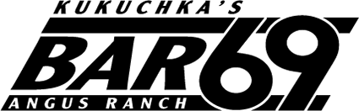

Bar 69 Ranch Summer 2024 Internship
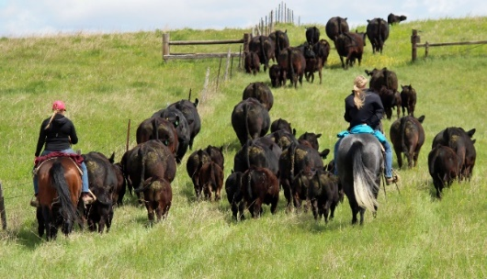
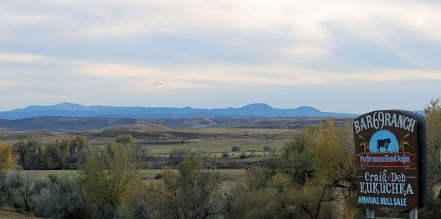
The Bar 69 Angus Ranch in Belle Fourche, South Dakota is seeking students from agricultural universities who are interested in learning the ins and outs of a purebred cow-calf and sheep operation. We focus on providing the best in maternal genetics through the sale of replacement heifers and registered yearling bulls, along with replacement ewe lambs and ram lambs. Our 36th annual bull sale will be held on April 4th, 2024.

This paid internship is an excellent opportunity to work on a diversified ranch located near the Black Hills in northwest South Dakota. This position requires a willingness to work with other ranch employees and owners. Long term interest in animal science/ranch management is preferred. Special consideration is given to students with equine experience. Students will receive hands- on training in ranching and ranch management. Housing and utilities are provided. Applicants must be enrolled as a student at a college or university to be considered.
Internship details:
- Who should apply: Students interested in livestock production and promotion
- What: paid internship, includes housing at the ranch
- When: May 10th-August 10th (actual days are flexible around curriculum)
- Where: Belle Fourche, SD
- To apply email the completed application form, resume, and cover letter to Deb Kukuchka at bar69angus@gmail.com
- Application due: February 10, 2024

Ranch activities
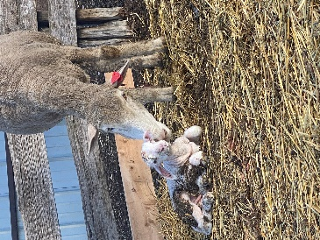
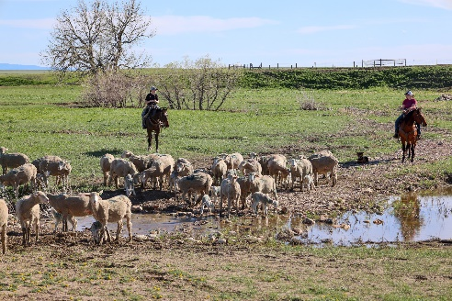
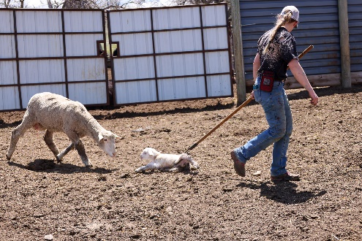
The first few weeks of the internship will include lambing. We shed lamb our ewes in two lambing’s in March and May. We begin processing ewes and lambs in mid-May, and hauling them to summer pastures.

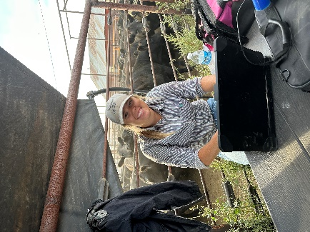
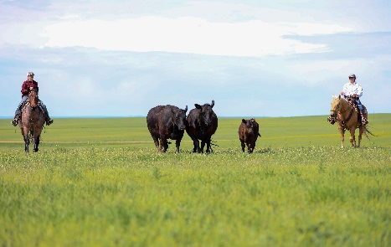
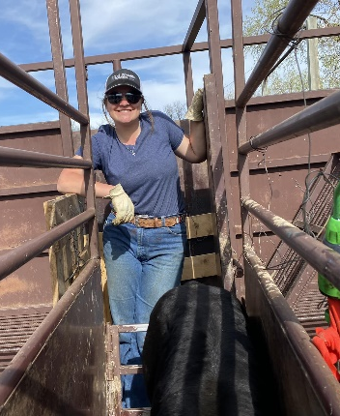
About the same time, we work the cows and calves. This includes branding, tattoos and shots. They are also moved to summer pasture at this time. Replacement heifers are ultra sounded for calving date and calf sex the first week of June. We use horses to sort cows and heat detect naturally, and we A.I. approximately 300 cows for 21 days. Once cattle are A.I.ed, they are sorted into pasture groups and turned out with herd bulls. We use range management skills to determine when we turn into pastures, and how long to stay there and use multi-species grazing on our ranch, which benefits our range condition. As we are a purebred Angus operation, records are essential. Interns will have the opportunity to learn how we keep our livestock and financial records.
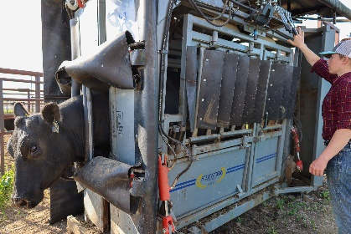

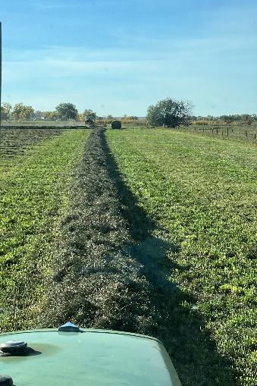
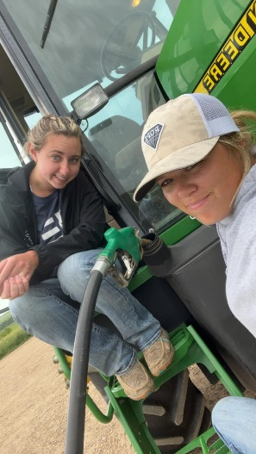
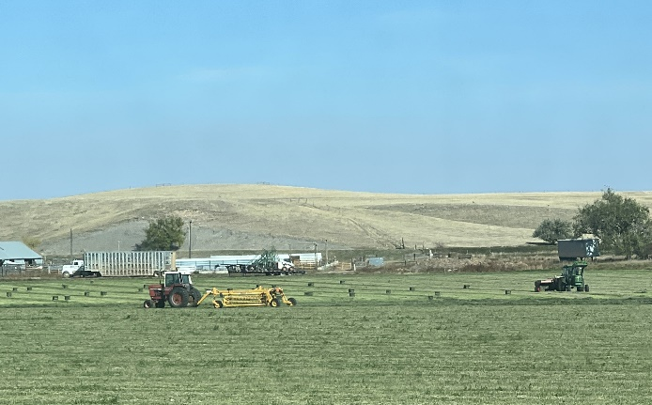
Summer time activities also focus on forage preparation and harvest. The ranch puts up over 1500 tons of irrigated alfalfa and grass hay each year, and raises corn and oats as well for our livestock. We are envisioning this as a livestock internship, but interns will learn about our farming operation as well.

Duties
Interns may be involved in Lambing, Branding, Herd Health Management, riding horseback , record keeping, feeding hay, cleaning stalls, processing cattle and sheep, fencing, heat detecting and artificial insemination. Intern may also assist with marketing and public relations for the purebred operation. All interns will receive an introduction to range management and ranch financial management. In addition, the intern may assist with irrigating and haying operations and assume other duties as assigned.

